**Supplementary material for “*Mountain ecosystem services affected by land use changes and hydrological control works in Mediterranean catchments”***

**S1. Supplementary information for the study area**

The study catchment has elevations ranging from 800 to 2080 m, it belongs to the Sub-betic mountainous area of the alpine Betic Mountains in SE Spain. The Upper Taibilla catchment (Figure 1 of the paper), (320 km2, ETRS89 - UTM 30 565029, 4226930 ) drains to the Taibilla reservoir, which provides water for domestic use and irrigation to a population of 2 million inhabitants of the Region of Murcia and the South of Alicante province. This catchment has a lithology consisting mainly of limestone at higher elevations and marls in valleys, all of Cretaceous, Oligocene, and Miocene origin (IGME, 1980). The dominant soil types are Calcaric Cambisols and Calcaric Regosols (IUSS Working Group WRB, 2015). With a mean annual rainfall and temperature of 530 mm and 13°C, respectively, the climate is between sub-humid and semiarid. The present land use is dominated by rainfed agriculture of cereals (barley) and tree crops like walnut (*Juglans regia*), vineyards, some low intensity grazing areas, shrublands, and forest (Figure 2 of the paper). The forest areas are dominated by pine species (*Pinus nigra salzmanii, Pinus pinaster*,and *Pinus halepensis*), while the shrublands consist of a mixture of *Erinacea anthyllis, Cytisus reverchonii, Rosmarinus officinalis*, *Thymus vulgaris*, and *Genista scorpius*.

Since the 1950s the population of this area has experienced a drastic decrease due to rural exodus to the cities and coastal areas, a common occurrence in many mountain areas in Spain. As a consequence, high agricultural abandonment took place in the catchment, as in many North Mediterranean mountain areas (García-Ruiz et al., 2011). In the 1970s, hydrological control works and reforestation were undertaken by the Spanish Government for erosion control and flood regulation purposes. These typical restoration actions were very common all over Europe (Piton et al., 2016). More than 120 check-dams were built within the Upper Taibilla catchment from 1973 onwards; the majority (87%) were gabion dams, the others were concrete closed structures. To achieve the most effective management, the construction of the check-dams was performed simultaneously with the reforestation of their drainage areas. Both check-dams and reforestations were part of integrated Forest and Hydrological Projects promoted by the Spanish Forest Administration (Figure 2 of the paper).

Sixty years after the start of reforestations, the total forest cover had increased by 85%; in contrast, agricultural land decreased by 63% from 1956 to 2012 (Pérez-Cutillas et al., 2018). Thus, the area experienced a greening-up, comparable to other high and medium-altitude mountain catchments (García-Ruiz et al., 2011).

Land use changes and the construction of check-dams have had large impacts on the catchment's sedimentary dynamics (Boix-Fayos et al., 2008; Quiñonero-Rubio et al., 2013; Quiñonero-Rubio et al., 2014), causing important morphological changes. These changes were mainly incision of the river bed and vegetation encroachment and stabilization of sedimentary deposits. Sediments were also retained by check-dams causing a sediment deficit that induced channel and riverbed erosion (Boix-Fayos et al., 2007). Land use changes were estimated to be responsible for about 50% of the reduction in catchment sediment yield (Boix-Fayos et al., 2008). Besides the morphological impact, the soil and sediment carbon stocks were also affected by the reforestation activities and land use changes (Boix-Fayos et al., 2009; 2015; Nadeu et al., 2015). The organic carbon reservoir of the soils and sediments increased by ̴24 %, due to the revegetation and morphological changes of the river bed (Halifa-Marin et al., 2019).

A detailed geomorphologic study of the Rogativa subcatchment showed that the main channel evolved from an aggradation period, with large sediment volumes coming from a well-connected agricultural catchment (1950s-1980s), to an incision and degradation phase after afforestation, land abandonment, and hydrological-control works (Boix-Fayos et al., 2007). Currently, the Rogativa catchment is passing through a transition phase again, with an armoured main channel and sediments being incorporated into the channel through gullies and bank erosion (Boix-Fayos et al., 2007; Nadeu et al., 2011).

Land use changes and construction of check-dams have also affected the hydrological properties of the catchment. A reduction in the discharge of 43% and an increase in the evapotranspiration of 57% in the catchment were estimated for a period of 60 years (Pérez-Cutillas et al., 2018), with a non-significant variation in the annual average precipitation from 1956 to 2012. For future climate conditions, Eekhout et al. (2018; 2019) found that in the Upper Taibilla precipitation will decrease with 4-25%, whereas runoff will increase (29-74%) due to an increase of extreme precipitation under projected future climate change. In these climate change scenarios, infiltration and soil water content are expected to decrease, leading to increased plant water stress. Under moderate climate change scenarios, soil erosion and sediment yield to the Taibilla reservoir are also expected to increase, while reservoir inflow tends to decrease (Eekhout et al. 2018; Eekhout and de Vente 2019).

**S2. Supplementary information for management plans**

Below we provide a short summary of each of the three plans, while Table 1 provides an overview of related investments:

1. National level: *National Plan of Priority Actions on Hydrological and Forestry Restoration,* *Erosion control and fight against desertification* (NPPARE, Ministerio de Medio Ambiente, 2001). The NPPARE is annexed to the National Forestry Plan (2002-2032) and its main objectives are erosion control, improvement of hydrological regimes, regulation of surface discharge, and the restoration, conservation, and improvement of the protective vegetation cover. The specific objectives of the plan are related to soil and vegetation restoration, hydrological regulation, aquifers recharge, erosion control, and protection of water infrastructures, including reservoirs. A prioritization system of second-order catchments was developed to apply the restoration actions. This is based on the technical and administrative facilities available to apply the actions and is combined with the use of an index based on the estimated average soil loss rates and the flood damage potential of the subcatchment. The reference value erosion rate for the implementation of correction measures in subcatchments is >50 t ha-1 year-1, but this threshold can be lowered to 25 and even 12 t ha-1 year-1 if the area has some specific or special interest for the region. It is a plan with a clear focus on the regulation of water and sediment fluxes in order to protect major infrastructures (reservoirs and hydraulic infrastructures). However, it also takes into account the positive side-effects of the control and restoration actions - such as improvement of the soil quality, vegetation, and biodiversity, recharge of aquifers, and protection of the quality of surface water (Ministerio de Medio Ambiente, 2001).
2. Regional level*: Action Plan of Forestry policy of the Murcia Region 2016-2020 (APFMR)* The general objective of the plan is linked to the concept of the ES provided by forests and points out the importance of recreational and protection services: “to guarantee that forests continue providing important benefits to society, through ecosystem benefits and the development of recreational and/or tourism activities, as well as the protection of inhabited areas through forest and hydrological correction works in the catchments” *(*Consejería de Agua, Agricultura y Medioambiente, 2016, page 6).

The reforestation activities and hydrological control works are related to Program 5 of the Plan: *“Hydrological restoration and soil conservation, linking with the National program of Forest and Hydrological Actions. Hydrological control works and restoration works for soil conservation and the fight against desertification (Forestry Planning Group)”* and the expected results of that program are related to: (i) soil conservation, runoff regulation, and sediments control, and (ii) synergic effects (in fact, improvement of ES): fight against climatic change (increase in carbon sinks) and against floods and droughts, increase in biodiversity, enrichment of the landscape.

1. *The catchment hydrological plan of the Segura River (Plan de Cuenca del Segura)* 2009-2021. This is divided in two periods; 2009-2015 and 2016-2021. There are two groups of measures in relation to the reforestation and hydrological control works planned. These are intended to accomplish the environmental objectives designed for the water bodies: (i) Measures for improvement of morphological conditions (*IPH4 “Instrucción de Planificación Hidrológica 4”*) and (ii) Measures for protection against floods (IPH 14). Additionally, there is another group of measures (IPH 2): Measures for reducing non-point contamination, where hydrological control works would have an indirect effect on the reduction of non-point contamination. The actions specified within these groups of measures are three-fold: hydrological correction works, actions for flood regulation, and reforestations.

Table 1. Investments according to the Planning Instruments with a stake in reforestation and hydrological control works in the Segura basin

|  |  |  |  |  |
| --- | --- | --- | --- | --- |
|  | Catchment plan First period  2009/2015 (18000 km2) | Catchment plan Second period  2015/2021 (18000 km2) | Forestry Plan Region of Murcia 2016/2020 (11000 km2) | National plan of priority actions on hydrological and forestry restoration, erosion control and fight against desertification (18000 km2) 2002-2008* |
| Hydrological and forest correction works | 29.54 M€ | 16.68 M€ | 5 M€ | 27.5 M€ (check-dams) |
| Floods regulation | 20.20 M€ | 4 M€ | n/a |
| Reforestations | 61.86 M€ | 61.86 M€ | 90.6 M€ |
| Others | n/a | n/a | - | 279.6 M€ |

*No information about later investments or modifications of the plan were available from the Ministry

**S3. Supplementary information for methods**

The values reflect the decision maker’s view of what to strive for or to achieve - including goals, objectives, and associated trade-offs (von Winterfeldt, 2013). The inclusion of values and facts in several phases of the process can lead to better decision making (Dietz, 2013; Gregory and Wellman, 2001). The value tree was used to derive weights (Stillwell et al., 1987) in step 4 (Figure 3 of the paper), by understanding the priorities of the decision makers as represented by the management plans. Furthermore, the value tree technique was used again in step 8 (section 3.5 of the paper).

In the first value tree (Step 3 Figure 3 and Figure 8A of the paper), values were derived from the analysis of the management plans. In all three management plans, the use of reforestation and hydrological correction works was driven by both protection of infrastructures and erosion and hydrological control values. Besides this, to a greater or lesser degree, the plans take into account the “side” (i.e. NPPARE) or “synergic” effects (i.e. APFMR) of the reforestation and hydrological control works that can be interpreted as ES (Step 3 and 4, Figure 3 of the paper).

The three plans use reforestation and hydrological control works as measures for erosion control and flood regulation, but the distinct plans pay differing degrees of attention to the economic benefits and ES provided by the catchment areas, as explained in section 2.2. Thus, several weight combinations were assigned (Table 2 of the paper) to capture the slightly different value perspectives of the different management plans on objectives. With each weight combination, a MCA was performed as: (i) regulating first, economy second, other benefits third (MCA1); (ii) regulating and economy equal, other benefits second (MCA2). These two weight combinations were related to APFMR (regional level plan with more economic restrictions). Related to the catchment plan (CP) a MCA weight combination was defined as (iii) all equal importance (MCA3). Related to the NPPARE (national level plan) two last weight combinations were (iv) all equal but economy less important (MCA4); (v) priority regulating (MCA5)(Table 2 of the paper). The weights of the different MCA were assigned with the expected value method, the groups of effects were arranged from the most important to the less important for each MCA (Table 3 of the paper). Furthermore, a series of MCA with those different weight combinations were run to evaluate the scenarios of management (Step 5, Figure 3 of the paper).

**S4. Supplementary information on sensitivity analysis**

To the test the influence of the MCA method on the results, the analysis were repeated using other MCA methods, following the review of Myšiak (2006). Although finally the weighted summation method was chosen because it is a reliable method (Hajkowicz, 2007), methodologically sound, easy to explain and transparent (Janssen, 2001).

We repeated all the analyses using the “Evamix” method. This method is well fitted to deal with an effects table with a mixture of qualitative and quantitative effects (Janssen and Herwijnen, 2017). The “Electre II” method was also applied, which is based on a pairwise comparison of the alternatives, thus using only the interval character of the scores in the evaluation of the effects table (Janssen and Herwijnen, 2017). The Regime method is well suited for working with qualitative and quantitative scores (Janssen and Herwijnen, 2017) and has been also tested. The relation between those three methods and the original used “Weighted summation” method is shown in Figure 1. A 64% of the relations between the scores and rankings resulted from the application of different methods showed a R2 > 0.7, supporting the idea that Weighted Summation is a reliable method in this study. There were some MCA runs where the two first alternatives exchanged positions. This type of analysis indicates the sensitivity of the analysis to the MCA method, as suggested by Myšiak (2006).

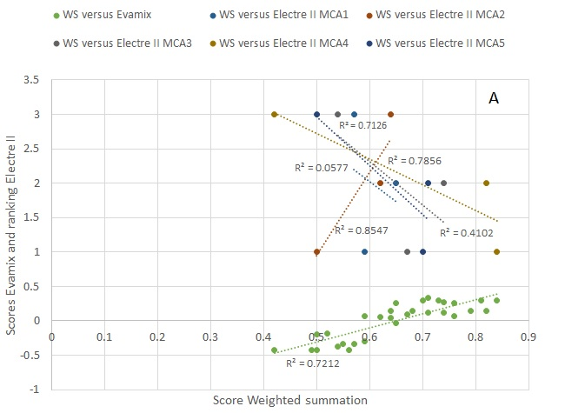

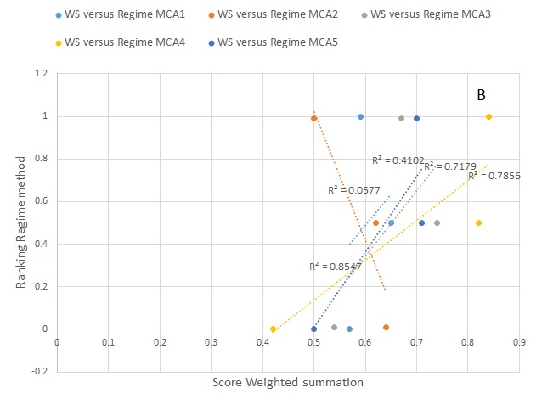

Figure 1. (A) Regression analysis between the scores resulted from the application of the Weighted Summation method and the scores and ranking resulting from the application of the Evamix method and Electre II methods, respectively for the different MCAs. (B) Scores resulted from the application of the Regime method versus scores resulted from the application of the Weighted Summation method for the different MCA carried out.

References are listed in the paper